_____ Yes, I would like to support a bright future through membership in the Minnesota FFA Foundation’s Legacy Club. I pledge $1,000 to support FFA chapters across the state, ensuring the growth and development of leaders for agriculture.

I would like to make my donation as (choose one of the following)
___ one payment of $1,000
___ two payments of $500
___ three payments of $333.33
___ four payments of $250

Please include your donation with this pledge card.

Thank you gift will be sent upon completion of the $1,000 donation.

______ I am not able to join the Minnesota FFA Foundation Legacy Club at this time. I look forward to staying connected to FFA happenings.

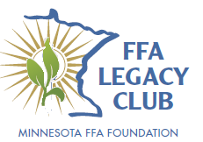
Name: _______________________________________
Address: _______________________________________
City, State, Zip: ____________________________________
Phone: _______________________________________
Email: _______________________________________

