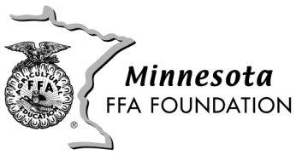
2020 Chapter Contribution Form

Chapter Name ___________________________________
Mailing address __________________________________
____________________________________
____________________________________

Contribution $________________

*Please submit before Dec. 31, 2020
*Contributions will credited towards 2020 fund drive unless indicated differently
*Contributing chapters will be recognized at the 2021 State FFA Convention

Send Your Contribution to: MN FFA Foundation, Box 365, Plainview, MN 55964

